Academic Affairs Updates

RE: Sonoran Crossing Medical Center

Dear Physicians and Faculty,

At this time Sonoran Crossing **has not** been established as a teaching hospital. As a result, we will need to adhere to the Medicare guidelines: residents, fellows, and medical students are not permitted to train at Sonoran Crossing Medical Center.

For questions, please contact AcademicAffairs@honorhealth.com or please reference the Medicare Learning Booklet, *Guidelines for Teaching Physicians, Interns, and Residents*.

Thank you for understanding.



**Priya Radhakrishnan, MD, FACP**

Chief Academic Officer

VP, Social Determinants of Health & Health Equity

PRadhakri@honorhealth.com



Graduate Medical Education Updates

**Continued Accreditation**

The Accreditation Council for Graduate Medical Education (ACGME) has granted continued accreditation to HonorHealth's Geriatrics Fellowship Program (Jessica Berdeja, MD - Program Director) and Clinical Informatics Fellowship Program (Craig Norquist, MD - Program Director)

**Kudos**

**Congratulation Dr. Radhakrishnan**

Dr. Priya Radhakrishnan was one of the winners for the Advancing Philanthropy Physician Award 2022!

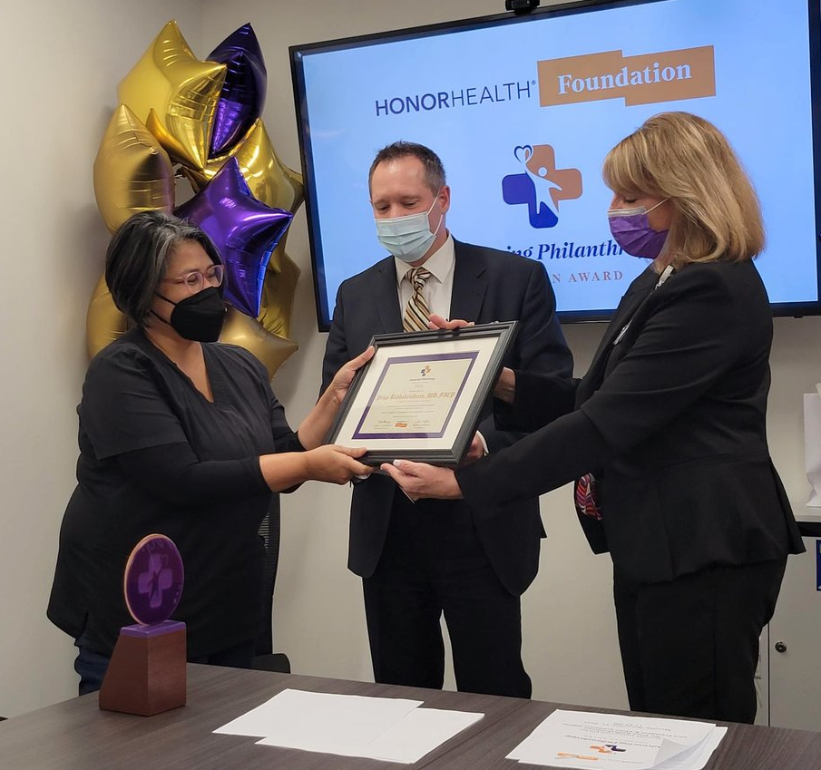

**Congratulations to Gastroenterology Fellowship Program on a successful Match Day!**

Dr. Faisal Mehmood & Dr. Andrea Schneider have matched into HonorHealth’s Gastroenterology Fellowship program.

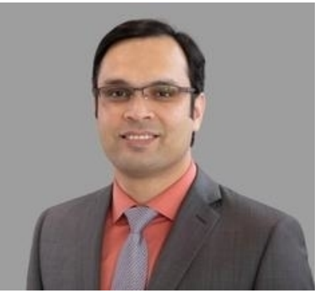Dr. Faisal Mehmood 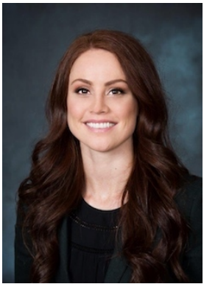Dr. Andrea Schneider

Continued Medical Education & ResQIPS Updates

What’s New in CME Activities for 2023

* Attendance will be taken by QR Code – to receive credit, simply type in your name and date of the event. Attendance is automatically received by the CME Office.
* Standard Survey Evaluation – Periodically, CME activities must assess impact on learners. HonorHealth uses a standard evaluation. Periodically, you will be asked to take the two-minute, multiple choice survey.

What’s Due for CME 2023

2023 Financial Disclosure Form

For accredited CME activities, everyone in control of content must disclose all financial relationships and it is up to the HonorHealth (CME Provider) to determine when relationships are relevant and need to be mitigated.

If you are a planner or speaker and haven’t completed the 2023 Disclosure, please open the QR code below.



Regularly Scheduled Series – Annual Summary Reports are due by the end of the year.

**Research, Quality Improvement & Patient Safety**

*Looking for a new scholarly activity, consider being the Chair of the ResQIPS Committee.* For more information contact the manager, [Catherine Wagner, EdD](mailto:catwagner@honorhealth.com)

Supported through the Reed Visiting Scholar program, **Dr. David Sklar** will consult and mentor faculty and residents. He is the Senior Advisor to the Provost Professor College of Health Solutions, Arizona State University. Dr. Sklar is an emergency medicine physician.

Health Equity Updates

**Social Determinants of Health (SDoH) Updates**

Our goal is to impact SDoH in our Community by developing structures and processes to initially identify and measure SDoH that are impacting our patients and communities’ specific needs**.**

**Key System Initiatives for 2023 Social Determinants of Health are:**

* Expand SDOH Screening and Referrals to HonorHealth Medical Group primary care clinics and inpatient high-risk cohort
* Promote health equity by achieving key health equity metrics (ACO Reach, AHCCCS, etc.)

**Health Catalyst University**

Congratulations to the food insecurity team on completing their Analytics and Improvement Certification Program (AICP) which includes the foundations, literacy, and practices of outcomes improvement through Health Catalyst

* Ben Gifford, DO – Clinical Informatics Fellow, PGY4
* Carol Mayer – Health Equity, Manager
* Cole Trotter, MD – Internal Medicine Resident, PGY2
* Elissa Thompson – Case Management, Network Director
* Jennifer Quillin – Desert Mission Food Bank, Living Well Program Director
* Kathryn Hernandez – Practice Administrator
* Lin Zhao, MD – Clinical Informatics Fellow, PGY4

With a special thank you to our executive sponsor, Dr. Priya Radhakrishnan, coach Liz DuToit and mentors Dr. Ed Kalpas and Dr. Rustan Sharer

**October Social with Women Physicians Leadership Council**

October Social led by directors Dr. Julie Crichton and Dr. Tiffany Proffitt at HonorHealth Thompson Peak Medical Centers

* Dr. Tiffany Pankow our newly appointed Vice President Chief of Caregiver Wellness and Patient Experience discussed the integration of wellness, leadership and quality patient care and highlighted HonorHealth’s wellness and peer support resources.
* Kara Greene shared the many ways HonorHealth Marketing and Communications can promote and highlight WPLC initiatives.
* Dr. Julie Kwatra shared the complex state of reproductive rights in Arizona in the wake of the Supreme Court’s overturning of Roe versus Wade.
* Kristen Vann expanded on how the Physician Relations team can help increase engagement and reach even more members of not just the HonorHealth community but expand our reach to recruit other talented physicians around the valley and the world!
* Dr. Tiffany Nelson, the Chief Executive Officer of Innovation Care Partners gave a rousing call to action for advocacy and action

For more information and participation please email [WPLC@honorhealth.com](mailto:WPLC@honorhealth.com) or visit the educational resources through the Library Services [portal](https://azhin.org/HHWPLC).

Health Equity Updates 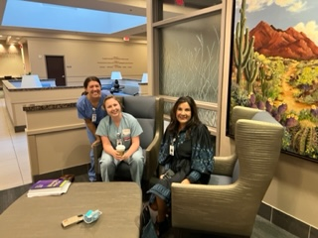 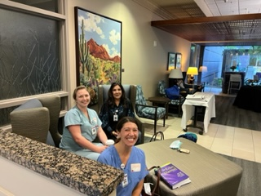

Photos from the October Social by WPLC.